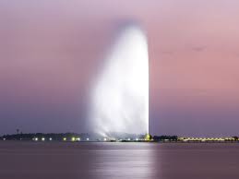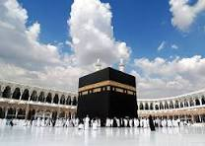

**Those two pictures show the most amazing and most visited places in Saudi Arabia.**

**The first picture shows Makkah and the second picture shows King Fahd’s Fountain.**